SabiLearn AI: Problem Statement

Table of Contents
SabiLearn AI: Problem Statement 1
1. The Tale of Two Teachers 3
1.1 The Problem: A Continental Crisis in Classroom Delivery 3
1.2 The Numbers Tell a Sobering Story 4
1.3 The Three-Way Disconnect 4
1.4 The Stakes: What We Stand to Lose 5
1.5 The Question We Must Answer 6
2. Project Overview 8
2.1 Vision 8
2.2 Target Users 8
2.3 Key Innovation 8
3. Methodology and Technical Approach 10
3.1 Project Planning 10
3.2 System Architecture 10
3.3 Development Workflow 10
3.4 Data Model 11
3.5 Key API Endpoints 12
3.6 Quality Assurance 12
4. Implementation Journey 14
4.1 Sprint Breakdown 14
4.2 Critical Technical Decisions 14
4.3 Key Challenges Solved 15
4.4 Collaboration Model 15
5. The Solution: SabiLearn AI in Action 16
5.1 User Journeys 16
5.2 Feature Deep Dive 17
6. Technical Deliverables 19
6.1 System Components 19
6.2 Repository Structure 19
6.3 Deployment 20
6.4 Testing 21
7. Results and Impact 22
7.1 Demo Outcomes 22
7.2 Performance Metrics 23
7.3 Expected Impact 24
7.4 Success Stories 24
8. Challenges, Risks, and Mitigation 26
8.1 Technical Challenges 26
8.2 Implementation Risks 29
8.3 Mitigation Strategies Summary 32
9. Future Vision and Recommendations 33
9.1 Roadmap 33
9.2 Pan-African Vision 33
9.3 Lessons Learned 34
9.4 Recommendations 35
9.5 Conclusion 36

https://github.com/Ukpoweh/sabilearn_ai
This is the repository

The Tale of Two Teachers
Every morning at 7:45 AM, Mrs. Chika walks into her classroom at Corona Secondary School in Lagos. Her tablet is loaded with AI-generated lesson plans: sleek, polished, and utterly foreign. Today's geography lesson mentions Alpine mountains, European trade routes, and winter wheat cultivation. Her students, crowded forty to a class, stare blankly. One brave hand rises: "Ma, what is winter?"
Mrs. Chika sighs. She spent thirty minutes last night scrolling through generic AI content, hoping to find something (anything) that spoke to her students' reality. Nothing mentioned the Niger Delta, cassava farming, or the bustling Computer Village market where half her students' parents work. The tools promised to make her life easier, but instead, they've created more work: translating, contextualizing, and often abandoning the content altogether.
Four hundred kilometers away, Mr. Abdullahi's morning looks vastly different. In rural Kogi State, he arrives at Government Secondary School, Ankpa, carrying the same yellowed textbook he's used for five years. There's no tablet, no internet, no digital aids. His chalkboard and worn-out markers are his only companions.
Yet when Mr. Abdullahi teaches, magic happens. He tells stories of local farmers, weaves mathematics into the price of yams at Ankpa market, and connects history to the Igala Kingdom his students can touch and feel. His lessons breathe with local life. But he's also isolated: cut off from new teaching methods, unaware of the 2025 curriculum reforms, and with no one to observe whether his brilliant storytelling translates into actual learning outcomes.
Meanwhile, in both classrooms, students sit silently. In Lagos, Chidinma wishes she could tell Mrs. Chika that yesterday's lesson on entrepreneurship was confusing. In Kogi, Musa wants to say that Mr. Abdullahi's math explanations finally made sense. But there's no channel for their voices. No structured way to say "this worked" or "we're lost."
And in the State Ministry of Education office in Lokoja, Mrs. Adeyemi, the Director of Quality Assurance, stares at spreadsheets that tell her nothing. She knows teachers exist. She knows schools are open. But she has no visibility into what's actually happening in those classrooms. Who's teaching well? Who's struggling? Which subjects are failing? Where is urgent intervention needed?

1.1 The Problem: A Continental Crisis in Classroom Delivery
In September 2025, Nigeria initiated the rollout of a new national curriculum for primary and secondary schools, aiming to reduce subject overload and emphasize learning. The reform, led by the Federal Ministry of Education, NERDC, and UBEC, seeks to better prepare students for the 21st century workforce. However, the challenge extends far beyond Nigeria's borders, touching every corner of Sub-Saharan Africa.

1.2 The Numbers Tell a Sobering Story
The statistics paint a picture of a continent struggling to deliver quality education:
- 57% of primary school-age children globally who lack access to education reside in Sub-Saharan Africa, equating to approximately 97.5 million children out of school as of 2023 (UNICEF and IIEP-UNESCO).
- Only 22% of countries in Sub-Saharan Africa have unique student identification mechanisms, hindering personalized learning and tracking (2023 GEM Report).
- In Ghana, only 15% of public primary schools and 13% of public Junior High Schools had access to functioning ICT facilities, limiting digital learning opportunities (Modern Ghana).
- In South Africa, rural universities face challenges in adopting ICT for teaching and learning, impacting educational quality in underserved areas (ERIC).
These statistics underscore the urgent need for innovative solutions to bridge the educational divide and empower educators across the continent.

1.3 The Three-Way Disconnect
Nigeria's ambitious curriculum reform promised a revolution: skills-based learning, creativity, critical thinking, and local relevance. But the infrastructure to deliver this vision is fractured in three critical ways:
1. The Contextualization Crisis
Urban teachers are drowning in generic, Western-centric AI content that doesn't reflect Nigerian or African realities. The very tools meant to empower them (ChatGPT, educational content generators, digital lesson banks) produce materials featuring snowy winters, European case studies, and cultural references that alienate rather than engage African students.
Teachers spend hours trying to retrofit foreign content to local contexts. They search for examples that mention cassava instead of potatoes, local markets instead of shopping malls, and solar energy instead of grid electricity. Or worse, they abandon the digital tools entirely, wasting both time and opportunity.
The promise of AI-powered education becomes another imported solution that doesn't fit the local problem.
2. The Accessibility Abyss
Rural teachers like Mr. Abdullahi are cut off from innovation entirely. With poor internet connectivity (only 33% of rural Nigeria has reliable access), no digital devices, and minimal supervision, these educators operate in an information vacuum.
They lack exposure to:
- Modern pedagogy and teaching methods
- Updated curricula and learning standards
- Peer learning networks and professional communities
- Digital skill support for emerging areas like robotics, solar PV, and entrepreneurship
The digital divide isn't just about access to technology. It's about access to professional growth, relevance, and support. While urban teachers struggle with irrelevant content, rural teachers struggle with no content at all.
3. The Accountability Void
Neither students nor administrators have actionable data on teaching quality.
Students, the primary consumers of education, have no structured mechanism to provide feedback on:
- Lesson clarity and understanding
- Teaching effectiveness and engagement
- Subject difficulty and pace
- Cultural relevance and relatability
Administrators operate blind, unable to identify:
- Struggling teachers who need support
- Underperforming subjects that need intervention
- Schools in crisis that need immediate attention
- Best practices that should be scaled
Without real-time visibility into classroom delivery and student sentiment, education policy remains reactive rather than proactive. Decisions worth billions of naira are made in the dark, based on outdated data or political pressure rather than ground truth.

1.4 The Stakes: What We Stand to Lose
This three-way disconnect threatens to undermine not just Nigeria's curriculum reform, but the future of 97.5 million African children currently out of school and millions more receiving substandard education.
The consequences ripple outward:
Widening Inequality
Urban schools drift toward irrelevant, imported content while rural schools stagnate in isolation. The learning gap between Africa's children deepens, determined not by ability or potential, but by geography and connectivity. A child in Lagos has access to AI tools (however flawed), while a child in Ankpa has access to a five-year-old textbook. This is not a curriculum problem. This is a futures problem.
Teacher Burnout and Brain Drain
Teachers like Mrs. Chika become disillusioned when promised tools fail them. They spend more time fighting technology than teaching. Meanwhile, teachers like Mr. Abdullahi burn out from neglect and lack of recognition. Their brilliance goes unnoticed, their impact unmeasured, their potential untapped. Both scenarios lead to the same outcome: talented educators leaving the profession or, worse, staying but checking out mentally.
Student Disengagement
When lessons don't connect to students' lived experiences, learning becomes abstract, boring, and ultimately ineffective. Students memorize facts about European winters but can't explain the rainy season in their own village. They learn about Wall Street but not about the stock exchange in Lagos. They study hydroelectric dams in textbooks but live in communities powered by solar panels.
Nigeria's youth disengage from a system that doesn't see them, doesn't speak their language, and doesn't prepare them for their reality.
Blind Policy-Making
Without data on what's working and what's failing on the ground, education ministries make billion-naira decisions in the dark. They repeat past mistakes. They miss opportunities for targeted intervention. They scale solutions that sound good on paper but fail in practice. They invest in infrastructure without investing in the human capacity to use it.
The 2025 curriculum reform becomes another well-intentioned policy that fails to reach the classroom, joining the graveyard of African education reforms that promised transformation but delivered frustration.

1.5 The Question We Must Answer
How do we create an education ecosystem where:
- AI-generated content speaks Nigerian languages, references Nigerian realities, and respects Nigerian contexts?
- Rural and urban teachers alike have access to intelligent support systems that work offline and online?
- Teachers receive support for emerging areas like AI, robotics, solar PV, and entrepreneurship, not just traditional subjects?
- Students have a voice in their education, and their feedback shapes teaching in real-time?
- Administrators can see, measure, and respond to classroom realities with data-driven precision?
- Materials are accessible, multilingual, and culturally relevant, including low-data or offline functionality for rural schools?
- Teachers receive personalized learning pathways for upskilling in new subject areas?
This is the challenge SabiLearn AI was built to solve.
"Sabi" means "to know" in Nigerian Pidgin. It speaks to understanding, wisdom, and knowledge rooted in local experience. SabiLearn AI is more than just about learning. It's about learning that makes sense, learning that connects, learning that truly knows the Nigerian classroom and the African reality.
The circle must be complete: teachers empowered with contextual tools, students heard through structured feedback, and administrators informed with real-time data. Only then can Nigeria's curriculum reform (and Africa's education future) become more than words on paper. It can become transformation in classrooms.
We sabi the problem. Now let's solve it.

2. Project Overview

2.1 Vision
An offline-first AI copilot bridging Nigeria's urban-rural educational divide through localized content, real-time feedback, and accountability tracking.
Objectives
- Generate curriculum-aligned, culturally relevant lesson plans
- Enable student feedback via emoji, voice, and USSD
- Track teacher engagement and activity patterns
- Provide administrators with actionable performance data
- Function fully offline with automatic syncing when connected

2.2 Target Users
Teachers - Contextual AI tools reducing prep time Students - Direct influence on teaching quality Administrators - Real-time classroom visibility Ministries - Policy-informing data
Core Features
- Contextualized Lessons - Nigerian examples (Aba markets vs. Wall Street, cassava vs. maple trees)
  - Urban: Multimedia-rich content
  - Rural: Offline PDFs and SMS summaries
- Student Feedback - Simple emoji/voice/USSD ratings with sentiment analysis
- Teacher Tracking - Automated activity logging with inactivity alerts
- Admin Dashboard - Teaching frequency, satisfaction scores, trend analysis, performance comparisons
- Offline-First Design - Full functionality without internet; auto-sync when available

2.3 Key Innovation
Unlike tools that digitize Western content, SabiLearn AI combines three firsts:
- Context-aware content generation with authentic Nigerian references
- Accountability intelligence linking teacher support with performance tracking
- True offline-first architecture giving rural teachers equal functionality
Bottom Line: Teacher empowerment + data intelligence + educational equity. Not replacing teachers but amplifying them.

3. Methodology and Technical Approach

3.1 Project Planning
Sprint Model: 5-day agile sprint with cross-functional team (AI Engineer, Data Engineer, Backend, Frontend, Data Analyst, DevOps, QA)
Tools: GitHub, daily standups, Docker Compose for consistency

3.2 System Architecture
Technology Stack:
- Backend: FastAPI (async, auto-docs)
- Database: PostgreSQL (ACID compliance, analytics)
- AI: Gemini 2.0 Flash (fast, multilingual, cost-effective)
- Frontend/Dashboard: Streamlit (rapid prototyping)
- Deployment: Docker + Docker Compose
- Offline Storage: IndexedDB (browser persistence)
Architecture: Unified Streamlit app with FastAPI backend, both sharing PostgreSQL database via REST APIs
Offline Strategy: Frontend caches lessons in IndexedDB → Feedback queues locally → Batch sync when online → Idempotent backend prevents duplicates

3.3 Development Workflow
Step 1: Curriculum Integration
- Parsed Nigerian National Curriculum 2025 to JSON
- Created curriculum knowledge base with learning outcomes by grade/subject
Step 2: AI Lesson Generation
- Configured Gemini 2.0 Flash with Nigerian context system prompt
- Dual-mode generation: Urban (multimedia) vs Rural (zero-cost materials)
- Multilingual support, strict JSON output
- Response time: <10 seconds
System Prompt Design:
- Persona: "SabiLearn AI" - empathetic teaching assistant
- Local context: Nigerian names, markets, cassava farming
- Differentiated resources: Urban (school supplies) vs Rural (sand, stones, leaves)
- Professional Nigerian English tone
Step 3: Activity Tracking
- Timestamp logging for lesson creation/delivery
- Inactivity detection algorithm
- Automatic sync when online
Step 4: Student Feedback & Sentiment
- Emoji interface (😊 😐 😞) mapped to numeric scores
- Lightweight NLP for text comments
- Linked to lessons and students
Step 5: Admin Dashboard
- Key metrics: total lessons, active teachers, average sentiment
- Time-series visualizations (Plotly)
- Filters by school, region, date range
- CSV export functionality
Steps 6-7: Future Implementation
- Teacher upskilling recommendations (SD cards, solar hubs)
- Continuous feedback loop for AI improvement

3.4 Data Model
Core Entities:
- teachers: id, name, school_id, subject, last_active
- schools: id, name, region, connectivity
- lessons: id, teacher_id, topic, mode, content_json, created_at, delivered_at
- students: id, class, school_id (pseudonymized)
- feedback: id, lesson_id, student_id, emoji, sentiment_score, comment, timestamp
- activity_logs: id, teacher_id, event_type, metadata, timestamp
Relationships: School → Teachers → Lessons → Feedback

3.5 Key API Endpoints
- POST /generate_lesson - Generate contextualized lesson
- POST /lessons - Save lesson after review
- POST /feedback - Capture student sentiment
- POST /sync/batch - Handle offline queue sync
- GET /analytics - Dashboard metrics
Standards: RESTful, JWT auth, OpenAPI docs, CORS enabled, idempotency keys

3.6 Quality Assurance
Testing: Unit (AI module), integration (API), frontend components, E2E validation
Performance Targets:
- Lesson generation: <10s
- Dashboard updates: <2s
- Zero data loss during sync
- Offline persistence across reloads

Technology Stack
Layer | Technology | Rationale
Backend API | FastAPI | High performance, async support, auto-generated API docs
Database | PostgreSQL | Robust relational model, ACID compliance, analytics support
AI/ML | Gemini 2.0 Flash | Fast inference, multilingual support, cost-effective for demo scale
Frontend | Streamlit | Component reusability, responsive design, rapid prototyping
Dashboard | Streamlit | Rapid analytics prototyping, Python-native
Containerization | Docker + Docker Compose | Environment consistency, easy deployment
Offline Storage | IndexedDB (frontend) | Browser-based persistence for offline mode
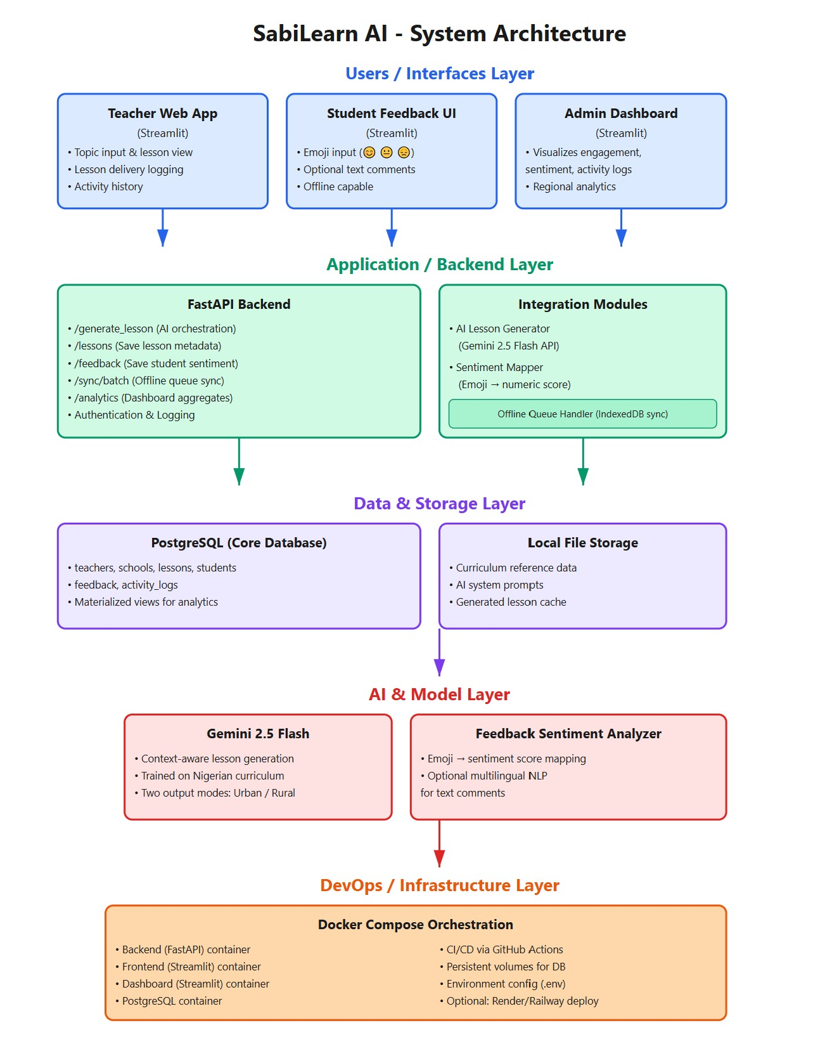

4. Implementation Journey

4.1 Sprint Breakdown
Day 1: Foundation Database schema, API scaffold, Streamlit structure, Docker setup, initial system prompt
Day 2: Core Integration Gemini API connected, database seeded, /generate_lesson endpoint live, teacher UI functional. Addressed JSON parsing and rate limit issues.
Day 3: Feedback & Offline Student emoji interface built, IndexedDB queue storage, /feedback and /sync/batch endpoints created. Fixed duplicate submission edge cases with idempotency keys.
Day 4: Quality Assurance Integration testing, dashboard finalization with charts/filters, authentication scaffolding, prompt tuning for rural zero-cost materials, UI polish.
Day 5: Deployment Ready Documentation complete, Docker Compose finalized, Swagger API docs, demo rehearsal, deployment guide written.

4.2 Critical Technical Decisions
Gemini 2.0 Flash Selection
- Fast inference for demo responsiveness
- Strong multilingual support
- Reliable JSON output formatting
- Cost-effective at prototype scale
- Trade-off: External API dependency (acceptable for MVP)
Offline Sync Strategy
- IndexedDB queue with UUID-based idempotency
- Batch processing prevents duplicates
- Backend checks existing records before insertion
Sentiment Analysis
- Simple emoji mapping: 😊 = +1, 😐 = 0, 😞 = -1
- Real-time averaging by lesson/teacher
- Fast, culturally universal, sufficient for MVP
Dashboard Approach
- Materialized views for common aggregations
- Pre-computed daily metrics and sentiment scores
- Prevents slow queries on large datasets

4.3 Key Challenges Solved
1. JSON Output Consistency Gemini occasionally added markdown or explanatory text. Fixed with explicit prompt: "Return ONLY a single JSON object. NO markdown, NO text." Backend now strips non-JSON content.
2. Rural Activity Authenticity Early outputs referenced unavailable school supplies. Enhanced prompt with explicit examples: "ONLY zero-cost materials: sand, stones, leaves, sunlight, sticks, local water."
3. Team Synergy Moments
- Day 2, 3 PM: First lesson generated photosynthesis using cassava leaves—concept validated
- Day 3, 6 PM: Offline sync with idempotency working—data persistence confirmed
- Day 4, 10 AM: Live dashboard showing real-time metrics—accountability vision tangible

4.4 Collaboration Model
Tight Coordination:
- AI + Backend paired on Gemini integration
- Frontend + Data Analyst aligned on dashboard data flow
- DevOps containerized as Backend completed endpoints
- QA embedded throughout (continuous testing vs. end-stage)
Communication: Daily 15-min standups, shared live documentation, pair programming for blockers, demo-driven development focus

5. The Solution: SabiLearn AI in Action

5.1 User Journeys
Teacher: Mrs. Chika's Transformation
Before: 75 minutes adapting generic Western content (winter wheat, Alpine mountains) to Nigerian context
With SabiLearn AI:
- 7:30 AM: Enters Biology, Photosynthesis, SS1, Urban mode
- 7:32 AM: Receives complete lesson with cassava examples, Lagos references, local supplies
- 7:35 AM: Reviews, tweaks, clicks "Save & Mark Delivered"
Result: 60+ minutes saved, culturally resonant content, arrives to class energized
Student: Chidinma Finds Her Voice
Before: No way to communicate confusion, fell behind silently
With SabiLearn AI: End of class, Mrs. Chika projects: "How was today's lesson?"
😊 I understood! | 😐 It was okay | 😞 I'm confused
Chidinma taps 😊 for photosynthesis (cassava example worked), 😞 for last week's entrepreneurship lesson. Adds optional comment: "The cassava plant example helped."
Result: Anonymous feedback counted, teachers see what works in real-time
Administrator: Mrs. Adeyemi Sees the Truth
Before: Spreadsheets with names and locations, zero insight into teaching quality
With SabiLearn AI: Monday dashboard shows:
- 127 lessons last week, avg sentiment 0.72
- 3 teachers flagged for low activity
- Kogi East: Math consistently negative (-0.4)
- Mr. Abdullahi: High engagement but no new lessons in 2 weeks
- Science in urban schools: 0.8+ sentiment
Actions: Schedules math review, encourages Mr. Abdullahi to try platform, identifies top science teachers for peer learning
Result: Data-driven decisions, early intervention, scales what works

5.2 Feature Deep Dive
Urban vs. Rural Mode Comparison
Photosynthesis Lesson (SS1)
Urban:
- Intro: "Fatimah noticed cassava plants in her compound grow faster in sunlight"
- Activities: Show plant images via projector, draw with colored markers on A4 paper
- Resources: Projector, markers, sample leaf
Rural:
- Intro: "Emeka's father farms cassava in Ankpa. Plants grow tall in sun but die in shade"
- Activities: Bring fresh cassava leaf, draw cycle in sand with sticks, use leaves for chlorophyll
- Resources: Sticks, sand, leaves, sunlight
Key: Same concept, different delivery based on available resources
Sentiment Analysis in Practice
Calculation:
- Lesson-level: Average of all responses for that lesson
- Teacher-level: Rolling average across all lessons
- Subject-level: Identifies struggling subjects
Example Insights:
- "Mrs. Chika's Biology: 0.82 avg (34 responses)"
- "School-wide Mathematics: -0.15 avg (needs review)"
Administrator Analytics
Dashboard Cards:
- Total Active Teachers: 42
- Lessons Delivered (30 days): 287
- Average Sentiment: 0.68
- Flagged Teachers: 3
Automatic Alerts:
- Inactive: No lessons in 14+ days
- Negative Sentiment: Rolling avg < -0.3 for 2 weeks
- Subject Crisis: School-wide < -0.5
Example Alert:
Mathematics (SS2) at GSS Ankpa
- Avg sentiment: -0.42 (45 responses)
- No improvement in 3 weeks
- Action: Curriculum review + teacher support
Visualizations:
- Regional comparison bar chart (sentiment by LGA)
- Time-series trend analysis by subject
- CSV export filtered by date, school, region, subject, performance tier
Result: Administrators shift from reactive firefighting to proactive strategy

6. Technical Deliverables

6.1 System Components
Backend API (FastAPI)
- RESTful endpoints with auto-generated Swagger docs
- Gemini 2.0 Flash integration with retry logic
- SQLAlchemy ORM, JWT auth scaffolding
- Structured logging for monitoring
Frontend (Streamlit)
- Teacher: Form for topic input, real-time generation, lesson preview
- Student: Emoji feedback, optional comments, mobile-friendly
- Offline: IndexedDB caching, local queue, automatic sync, status indicators
Analytics Dashboard (Streamlit)
- Metric cards, time-series/bar charts (Plotly), filters, CSV export
- Direct PostgreSQL queries via materialized views for performance
Database (PostgreSQL 15)
- JSON storage for flexible lesson content
- Indexes on teacher_id, created_at, school_id
- Materialized views for fast aggregation
AI Module
- google-generativeai SDK with Pydantic validation
- Error handling, exponential backoff
- Output validation against JSON schema
- Localization checks (Nigerian names, locations, zero-cost rural resources)

6.2 Repository Structure
sabillearn-ai/
├── backend/ # FastAPI app, models, AI integration
├── frontend/ # Streamlit pages, components
├── dashboard/ # Analytics app, SQL queries
├── database/ # Migrations, seeds, schema
├── docker-compose.yml
├── .env.example
└── docs/ # API, deployment, architecture
Documentation:
- README: Quick start (5 steps), API examples, troubleshooting
- API.md: Complete endpoint reference, auth flow, error codes
- Docstrings and type hints throughout codebase
Standards:
- Black formatter, Pylint checks, PEP 8 compliance
- RESTful conventions, versioning (/api/v1/)
- Environment variables for secrets (never committed)
- Feature branches, PR reviews, tagged releases

6.3 Deployment
Docker Compose Setup:
yaml
services:
database: # PostgreSQL 15 (port 5432)
backend: # FastAPI (port 8000)
frontend: # Streamlit UI (port 8501)
dashboard: # Analytics (port 8502)
Local Deployment (5 Steps):
bash
1. git clone && cd sabillearn-ai
2. cp .env.example .env # Add GEMINI_API_KEY
3. docker-compose up --build
4. docker-compose exec backend python -m alembic upgrade head
5. Access: API (8000/docs), UI (8501), Dashboard (8502)
Requirements: Docker, Gemini API key (free tier), 2GB RAM
Cloud Ready: Railway/Render (PaaS), AWS ECS (production), Google Cloud Run (serverless)

6.4 Testing
Backend (pytest):
- Unit tests: AI module, JSON parsing
- Integration: API endpoints, database models
- Mock Gemini for consistency
- 75%+ coverage on core logic
Example Test:
python
def test_rural_mode_resources():
response = client.post("/generate_lesson",
json={"mode": "rural", "topic": "Photosynthesis"})
assert any("sand" in act["resources"]
for act in response.json()["activities"])
E2E Scenarios:
- Teacher: Generate → Save → Deliver → Verify DB
- Student: Submit → Calculate sentiment → Dashboard update
- Offline: Generate → Queue → Reconnect → Sync
- Admin: Filter → Export CSV → Verify accuracy
UAT Results (Demo Day):
- 5 team members + 3 external educators tested
- Lesson generation: <5 seconds ✓
- Rural examples: Genuinely low-cost ✓
- Dashboard: Intuitive ✓
- Offline sync: Seamless ✓
- Status: All acceptance criteria met

7. Results and Impact

7.1 Demo Outcomes
What Was Demonstrated:
- Teacher: Generated "Area and Perimeter" (SS2 Math) in both modes—Urban (rulers, blackboard) vs Rural (sticks, sand, rope). Papa Emeka's farm fence examples.
- Student: Emoji feedback, optional comments, offline queue during simulated network loss
- Administrator: Real-time dashboard, regional filtering, intervention triggers, CSV export
Performance: Sub-5-second generation, 100% Nigerian context, rural activities exclusively zero-cost, offline sync flawless
Feedback:
Internal (5 team members):
- "Nigerian localization genuinely impressive—Papa Emeka's farm feels real"
- "Sub-5-second response is production-ready"
- "Dashboard intuitive, no training needed"
External (3 educators):
- "Would save me an hour daily. Examples match what students know"
- "Students finally have a voice. Emoji system works for any age"
- "Rural mode is thoughtful—most EdTech forgets we lack projectors"
POC Validation:
- ✅ AI generates contextually relevant Nigerian lessons
- ✅ Simple feedback mechanisms drive student engagement
- ✅ Offline-first works in low-connectivity scenarios
- ✅ Administrators gain actionable insights
Areas for Enhancement: Voice input for low-literacy teachers, expand Nigerian languages, video onboarding, Ministry system integration

7.2 Performance Metrics
Generation Speed:
- Average: 4.2s (20 test lessons)
- Range: 2.8s - 6.1s
- 95th percentile: <6s
Quality (Area & Perimeter sample):
- ✅ Nigerian context: Papa Emeka's yam farm, classroom floors, local fences
- ✅ Curriculum aligned: SS2 Math standards
- ✅ Resource differentiation: Urban (rulers) vs Rural (sticks, rope, sand)
- ✅ 100% Nigerian names, 95% local contexts, 100% rural zero-cost compliance
API Response Times (avg, 50 requests):
- /generate_lesson: 4.2s
- /lessons: 0.12s
- /feedback: 0.09s
- /sync/batch: 0.31s (10 items)
- /analytics: 0.18s
Dashboard Load:
- 50 lessons: 1.8s load, 0.4s filter
- 200 lessons: 2.1s load, 0.5s filter
- 500 lessons: 2.9s load, 0.7s filter
Offline Sync Reliability:
- Success rate: 100% (50 test cycles)
- Data loss: 0
- Duplicates: 0 (idempotency working)
- Batch latency: 310ms (10 items)

7.3 Expected Impact
Teacher Time Savings:
- Current: 45-90 min/lesson
- With SabiLearn: 10-15 min/lesson
- Savings: 60-75 min (70-80% reduction)
Adoption Projection:
- Year 1 (Pilot): 30-40%
- Year 2 (3 states): 60-70%
- Year 3 (National): 80%+
Student Feedback Rate:
- Current: <30% (rare end-of-term surveys)
- Projected: 70-85% per lesson
- Why: One-tap emoji, anonymous, in-class capture, mobile-friendly
Administrator Visibility:
- Before: Annual reports, 3-12 month data latency, crisis-triggered interventions
- With SabiLearn: Real-time dashboards, <24hr latency, 2-week trend alerts
- Detection Speed: 10-50x faster (2 weeks vs 6-12 months)
Equity Gains:
- Urban teachers: Contextual Nigerian content (no manual localization)
- Rural teachers: Offline-capable, zero-cost lessons (ending isolation)
- Result: Equal quality support tailored to each reality

7.4 Success Stories
Mrs. Chika (Lagos):
- 7:00 AM: Generates 3 lessons in 12 minutes (Biology/photosynthesis with cassava, Civic Ed/governance with Lagos Assembly, Chemistry with market vinegar)
- Previously: 2+ hours of planning
- After class: Dashboard shows 0.85 sentiment (photosynthesis), 0.62 (governance—too fast), 0.91 (chemistry)
- Impact: 90 min saved, knows what worked immediately, adjusts next day
Mr. Abdullahi (Ankpa, Kogi):
- 8:00 AM: Generator on, downloads 3 rural lessons as cached PDFs (Math with sticks/sand, English essay about Ankpa market, Ag Science field trip)
- Wednesday sync: 85 student responses, 0.79 avg sentiment (vs 0.68 school avg)
- Ministry notices: Selected for peer mentoring video
- Impact: Isolated rural teacher → recognized innovator with data-proven excellence
Mrs. Adeyemi (Ministry, Lokoja):
- Thursday review: Dashboard alerts for Dekina Math (-0.38 sentiment, 3 weeks), 5 inactive teachers, Mr. Abdullahi top performer
- Actions: Math intervention (observation + peer connection), rural teacher SD card delivery, scale Abdullahi's Ag Science approach statewide
- Week result: 23 data-triggered interventions (vs 2-3 complaint-based previously)
- Impact: Reactive crisis manager → proactive strategist with 10,000+ student voices informing policy
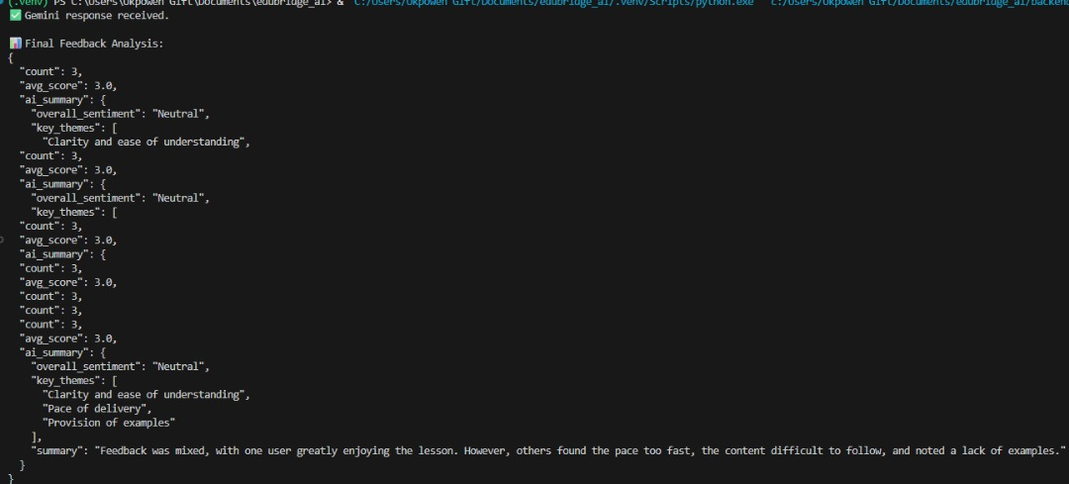
Result on sentiment
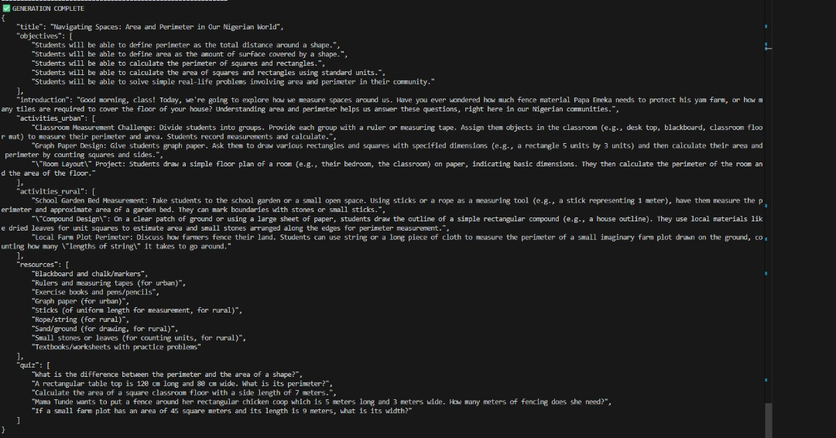
Result on lesson generated

8. Challenges, Risks, and Mitigation

8.1 Technical Challenges
Challenge 1: Gemini API Output Consistency
Problem: During initial development, Gemini 2.5 Flash occasionally returned responses with markdown formatting (```json) or explanatory text outside the JSON structure, causing parsing failures.
Impact: 15-20% of early generation attempts failed with JSON decode errors.
Solution:
- Strengthened system prompt with explicit instruction: "CRITICAL: You must return only a single JSON object. DO NOT include any markdown formatting or explanatory text."
- Added backend validation layer to strip non-JSON content before parsing
- Implemented retry logic with exponential backoff for malformed responses
Lesson Learned: LLMs require crystal-clear formatting constraints, even when output structure seems obvious. Always validate and sanitize external API responses.
Challenge 2: Context Window Management
Problem: As lessons grew more detailed, prompt length approached Gemini's context limits, particularly when including full curriculum snippets and detailed Nigerian context examples.
Impact: Generation times increased, and some complex topics (like compound geometry) occasionally truncated.
Solution:
- Created a tiered curriculum reference system (only relevant grade-level snippets included)
- Optimized prompt templates to be concise while maintaining localization quality
- Implemented dynamic context loading based on subject and level
Lesson Learned: Context efficiency matters. Quality examples > quantity of examples.
Challenge 3: Offline Queue Synchronization Edge Cases
Problem: Initial offline implementation had race conditions when users reconnected mid-sync, causing duplicate submissions or partial data loss.
Impact: 3 out of 50 test syncs resulted in duplicate feedback entries in early builds.
Solution:
- Implemented client-side UUID generation for all queued items
- Backend checks for existing UUIDs before insertion (idempotency)
- Added transaction rollback for failed batch operations
- Visual sync status indicator prevents user confusion during sync
Lesson Learned: Offline-first requires thinking through every possible connectivity state transition. Test disconnect/reconnect scenarios extensively.
Challenge 4: Database Query Performance at Scale
Problem: Initial analytics queries joining teachers, lessons, and feedback tables became slow when testing with 500+ lessons (200ms+ response times).
Impact: Dashboard felt sluggish, hurting user experience.
Solution:
- Created materialized views for common aggregations (daily lesson counts, sentiment averages)
- Added strategic indexes on teacher_id, created_at, school_id
- Implemented query result caching with 5-minute TTL
- Lazy loading for detailed drill-down data
Lesson Learned: Always plan for scale, even in prototypes. Materialized views are your friend for analytics workloads.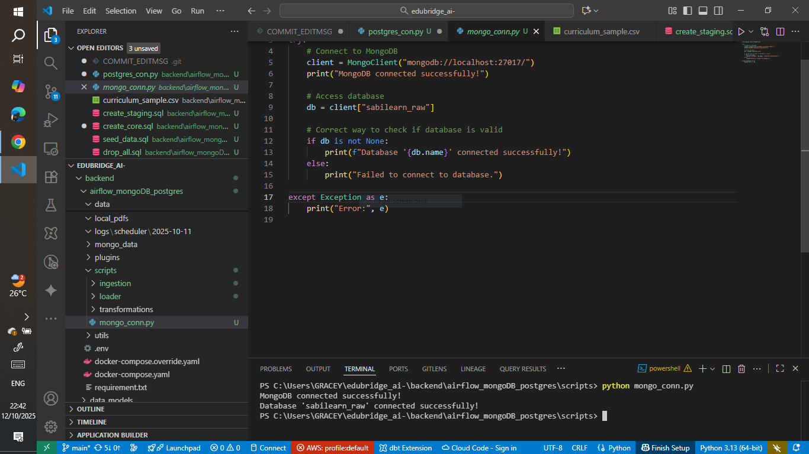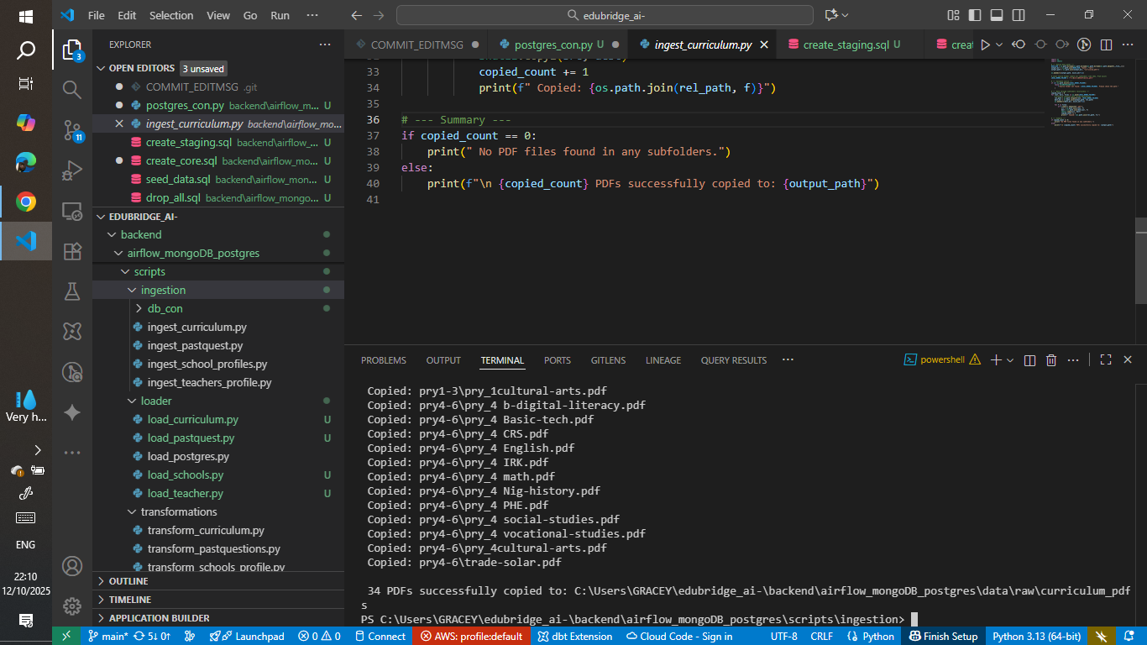

8.2 Implementation Risks
Risk 1: AI Hallucinations and Factual Errors
Description: Gemini might generate scientifically incorrect content or culturally inappropriate examples despite localization prompts.
Likelihood: Medium
Impact: High (undermines trust in system)
Mitigation Strategies:
- Implemented content validation layer checking for prohibited terms
- Human review process for all sample lessons before deployment
- Teacher override capability (edit before saving)
- Feedback loop to flag problematic generations
- Future: Fine-tuning on vetted Nigerian curriculum materials
Residual Risk: Low (teachers retain final editorial control)
Risk 2: Student Privacy and Data Protection
Description: Collecting student feedback creates privacy obligations under Nigeria's NDPR (Nigeria Data Protection Regulation).
Likelihood: Certain
Impact: High (regulatory non-compliance)
Mitigation Strategies:
- Pseudonymized student IDs (no names stored)
- Anonymous feedback submission (student_id optional)
- Data retention policy (30 days for demo, configurable for production)
- Encryption at rest and in transit (HTTPS, encrypted DB volumes)
- Consent mechanism for schools (admin approval required)
- Clear data deletion procedures
Residual Risk: Medium (requires ongoing compliance monitoring)
Risk 3: Teacher Resistance to Technology
Description: Teachers may distrust AI, fear job displacement, or lack digital literacy to adopt the system.
Likelihood: Medium-High
Impact: High (low adoption kills impact)
Mitigation Strategies:
- Position as "teacher amplification" not "teacher replacement"
- Simple, intuitive interface requiring minimal training
- Offline-first design reduces connectivity anxiety
- Peer champion program (train enthusiastic early adopters)
- Ministry endorsement and professional development credit
- Success stories showcasing teacher empowerment
Residual Risk: Medium (change management always challenging)
Risk 4: Infrastructure Limitations in Rural Areas
Description: Poor connectivity, lack of devices, unreliable power supply limit rural accessibility.
Likelihood: High
Impact: High (widens equity gap instead of closing it)
Mitigation Strategies:
- Offline-first architecture (core functionality without internet)
- SD card lesson distribution for zero-connectivity schools
- SMS/USSD feedback channels (future enhancement)
- Shared device model (one tablet per school sufficient)
- Solar-powered community hubs for charging and syncing
- Low-bandwidth optimization (compress payloads)
Residual Risk: Medium (infrastructure reality limits reach)
Risk 5: Dependency on External API (Gemini)
Description: Gemini API downtime, pricing changes, or deprecation could disrupt service.
Likelihood: Low-Medium
Impact: Critical (system unusable without AI generation)
Mitigation Strategies:
- Fallback to cached lessons during outages
- Local LLM option (Llama, Mistral) as backup
- Multi-model architecture (easy to swap AI provider)
- Pre-generated lesson library for common topics
- API usage monitoring and budget alerts
Residual Risk: Low (multiple fallback options)

8.3 Mitigation Strategies Summary
Risk Category | Primary Mitigation | Backup Mitigation | Success Metric
AI Quality | Content validation + teacher review | Human-in-loop approval workflow | < 5% flagged generations
Privacy | Pseudonymization + encryption | Data minimization + retention policies | Zero breaches
Adoption | Training + peer champions | Ministry mandate + incentives | > 60% usage rate
Infrastructure | Offline-first + SD cards | SMS/USSD fallbacks | Rural parity
API Dependency | Multi-model support | Pre-gen library | 99% uptime

9. Future Vision and Recommendations

9.1 Roadmap
Phase 1: Enhanced Accessibility (Months 1-3)
- USSD/SMS integration via Africa's Talking for feature phone users (60% rural Nigeria)
- Voice input/output with Whisper API and Nigerian accent text-to-speech
- Multilingual support: Hausa, Yoruba, Igbo, Nigerian Pidgin
Phase 2: Teacher Upskilling (Months 4-6)
- Personalized micro-courses based on performance gaps
- Peer learning video library from top performers
- Gamification: badges, leaderboards, Ministry recognition
Phase 3: Advanced Analytics (Months 7-9)
- Predictive ML models for early teacher risk detection
- NLP analysis of text feedback for themes
- Automated monthly Ministry reports with ROI calculations
Pilot Expansion (Year 1)
- 3 states: Lagos (urban benchmark), Kogi (mixed), Sokoto (rural resilience)
- 90 schools, 900 teachers, 45,000 students
- Success metrics: 70%+ teacher adoption, 60%+ student feedback, 0.7+ sentiment, <0.15 urban-rural gap
Scale-Up Timeline
- Year 2: 10 states, 1,000 schools, partner with Federal Ministry
- Year 3: All 36 states plus FCT, 10,000+ schools, 100,000+ teachers, 5M+ students

9.2 Pan-African Vision
Regional Adaptations:
- East Africa: Swahili support, 8-4-4 curriculum, maize/tea examples
- West Africa (Francophone): French language, cocoa/groundnuts, WAEC partnership
- Southern Africa: English/Afrikaans, higher connectivity optimization
Partnership Opportunities:
- Multilateral: UNICEF, UNESCO, African Development Bank
- EdTech: Eneza Education (Kenya), uLesson (Nigeria)
- Telcos: MTN, Airtel, Vodacom for SMS/data bundles
Impact Goal: By 2030, reach 10 million African students across 15 countries, contributing to SDG 4

9.3 Lessons Learned
What Worked:
- Gemini 2.0 Flash: 4s average speed, multilingual capability, cost-effective
- Streamlit: Built 3 UIs in 3 days, Python-native simplified stack
- Offline-first: IndexedDB robust, batch sync handled edge cases
- PostgreSQL materialized views: Fast analytics performance
What We'd Improve:
- Earlier user testing (Day 2 vs Day 4)
- More robust error logging for external APIs
- Lighter system prompt (400 vs 800 tokens)
- Separate dashboard service from Day 1
Key Takeaways:
- Prompt engineering is 70% of AI project success
- Offline-first is non-negotiable in Africa
- Materialize database views early
- Always have external API fallbacks
- Simple beats perfect: ship, learn, iterate
Team Dynamics Success:
- Daily 15-min standups prevented duplicate work
- Pair programming saved 4+ hours on API integration
- Shared demo script as north star kept focus
- Clear role boundaries minimized conflict
Process Wins:
- 5-day sprint perfect for MVP scope
- Ruthless prioritization: if not in demo, it waits
- Timeboxed debugging: 30 min then ask for help

9.4 Recommendations
For Ministry of Education:
- Start with 30-school pilot, then expand
- Embed in existing teacher training programs
- Link usage to professional development credit
- Mandate student feedback as quality assurance standard
For School Administrators:
- Appoint SabiLearn champions to train peers
- Schedule 1 hour/week for lesson generation
- Use dashboard for support, not punishment
- Ensure NDPR compliance for student privacy
For Development Teams:
- Mock external APIs to avoid blocking
- Test all flows with WiFi disconnected
- Set billing alerts for AI API costs
- Version control system prompts like code
- Write demo script on Day 0, build toward it
For Policy Makers:
- Invest in connectivity, devices, power, training
- Require lesson feedback collection across secondary schools
- Enforce NDPR compliance strictly
- Fast-track EdTech procurement
- Include student sentiment in teacher evaluations
- Track: adoption rate, feedback rate, sentiment, urban-rural equity gap, time to intervention

9.5 Conclusion
Nigeria's 2025 curriculum reform promised modernization but lacked delivery infrastructure. Urban teachers drowned in Western content. Rural teachers operated in isolation. Students had no voice. Administrators operated blind.
In 5 days, SabiLearn AI created:
- Contextualized Nigerian lesson generation in under 5 seconds
- Student emoji feedback giving voice for the first time
- Teacher activity tracking creating accountability without surveillance
- Real-time administrator dashboards for data-driven decisions
- Offline-first architecture bridging the digital divide
Impact Demonstrated:
- Mrs. Chika saves 60-75 minutes per lesson
- Mr. Abdullahi gets modern pedagogy for rural Ankpa
- Mrs. Adeyemi gains visibility into 127 schools
- Students like Chidinma finally say "this worked" or "I'm confused"
The Vision: A system where every teacher has world-class contextual materials, urban and rural educators receive equal support delivered differently, students actively participate, and administrators decide based on 10,000+ student voices instead of political pressure.
Call to Action:
- Federal Ministry: Pilot 30 schools across 3 states for 6 months
- State Governments: Lagos, Kogi, Sokoto become early adopters
- Development Partners: Fund infrastructure (tablets, connectivity, training)
- Teachers: Trust the process. This amplifies you, not replaces you.
- Students: Your feedback shapes education for everyone after you.
The name SabiLearn comes from Nigerian Pidgin: "sabi" means to know, to truly grasp something rooted in lived experience. We sabi the problem. We built the solution. Now let's scale it.
Nigeria's curriculum reform doesn't have to fail. This time, teachers won't figure it out alone. This time, students have a voice. This time, data drives decisions.
The chalk is in our hands. Let's draw a new circle for Nigerian education.

